Activity: Group Discussion
Group 1: Hardware Concepts Related to Operating Systems
Discussion topic: How does computer hardware influence the design and performance of an operating system?
Guiding questions:
- What roles do the CPU, registers, memory, and I/O devices play in OS operation?
- How does hardware support multitasking and multiprogramming?
- Why are interrupts and privileged instructions important?
- What problems may occur if hardware does not support memory protection?

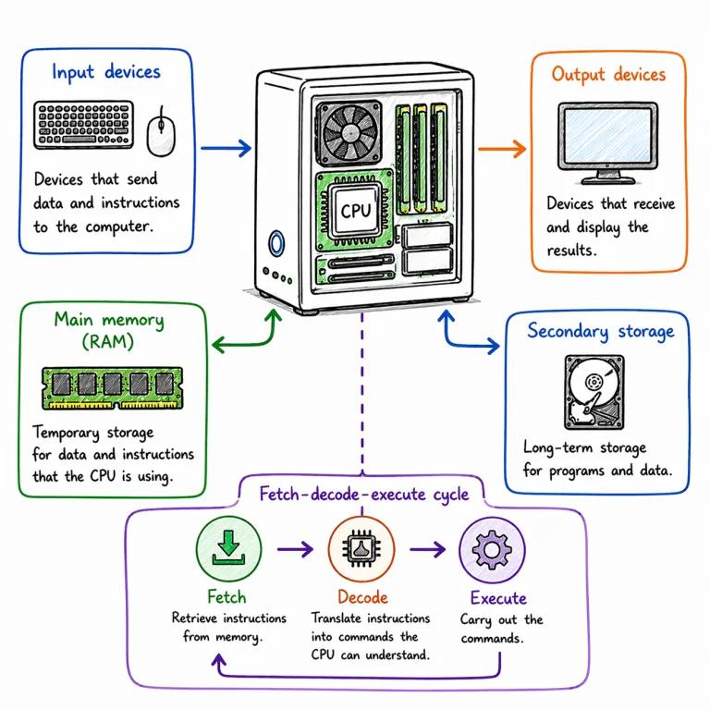
Group 2: CPU States
Discussion topic: Why are CPU operating modes and process states essential for secure and efficient computing?
Guiding questions:
- What is the difference between user mode and kernel mode?
- How does a system call transfer control to the OS?
- Why does a CPU switch between processes?
- What happens when a program attempts a privileged instruction in user mode?
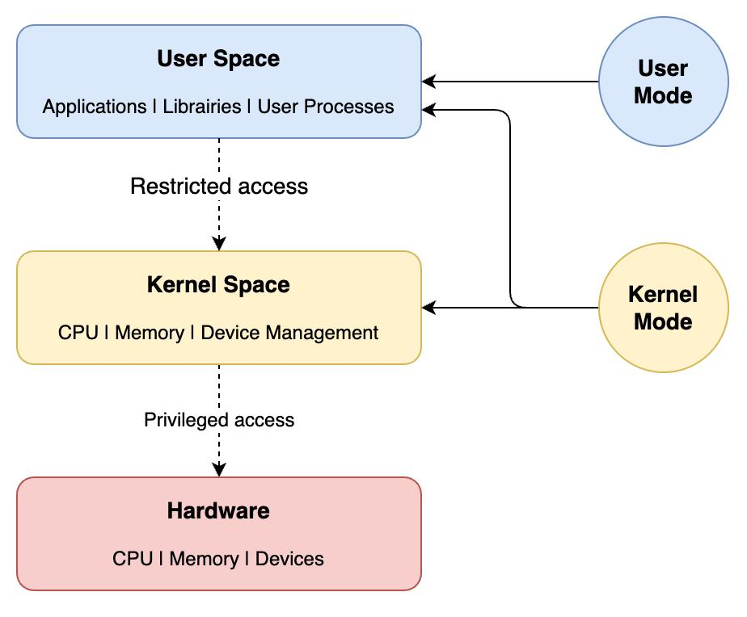
Group 3: Memory Hierarchy
Discussion topic: Why can't computers use only the fastest memory for all storage requirements?
Guiding questions:
- Compare registers, cache, RAM, SSDs, and hard disks.
- How do speed, capacity, and cost differ across memory levels?
- What are cache hits, cache misses, and locality of reference?
- How does virtual memory help when RAM is insufficient?
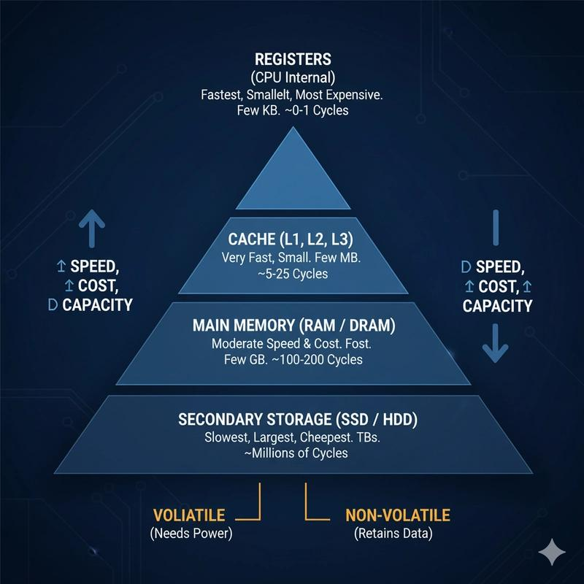

Group 4: Microprogramming
Discussion topic: How does microprogramming help a processor execute machine instructions?
Guiding questions:
- What is microprogramming?
- What are microinstructions and control memory?
- How does a control unit generate signals to coordinate CPU components?
- Compare microprogrammed control with hardwired control.


